Project Report

# Estimation of Business Expenses

# 1.INTRODUTION

* **Identify the expenses**: The first step in estimating business expenses is to identify all the costs associated with running your business. This includes fixed costs such as rent, salaries, and utilities, as well as variable costs such as raw materials and supplies.

\***Categorize the expenses**: Once you have identified all the expenses, categorize them into different categories such as direct and indirect costs. This will help you understand which expenses are essential for your business and which ones can be reduced or eliminated.

\***Estimate the costs**: After categorizing the expenses, estimate the cost of each category. This can be done by analyzing historical data or by using industry benchmarks.

\***Create a budget**: Finally, create a budget that outlines your estimated expenses for the upcoming period. This will help you plan your finances and ensure that you have enough funds to cover all your expenses.

## 1.1Overview

Business expenses are the costs incurred by a company to generate revenue. These costs can be categorized into different types such as fixed, variable, operating, and non-operating expenses. Fixed expenses are costs that remain constant over a period of time, while variable expenses change with the level of production or sales. Operating expenses are essential for the daily activities of a business, while non-operating expenses are related to debts and the disposal of assets.

To estimate business expenses, you need to identify all the costs associated with running your business, categorize them into different categories, estimate the cost of each category, and create a budget that outlines your estimated expenses for the upcoming period.

## 1.2 Purpose

Estimating business expenses is important for budgeting, evaluating cash flow, managing client expectations, and predicting the market cost of a project. It helps you understand which expenses are essential for your business and which ones can be reduced or eliminated

# 2. PROBLEM DIFFINITION THINKING

# Screenshot (9).pngScreenshot (8).png3. RESULT

## Dashboard and Story

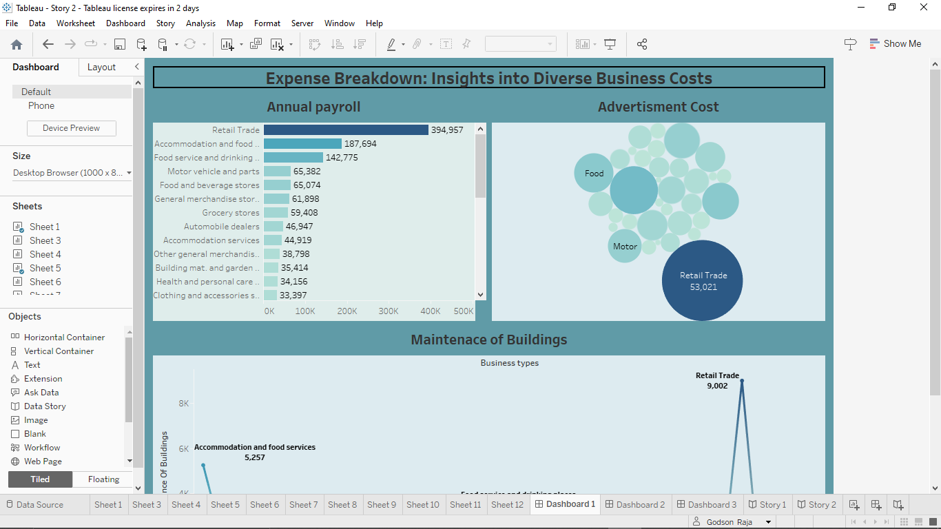

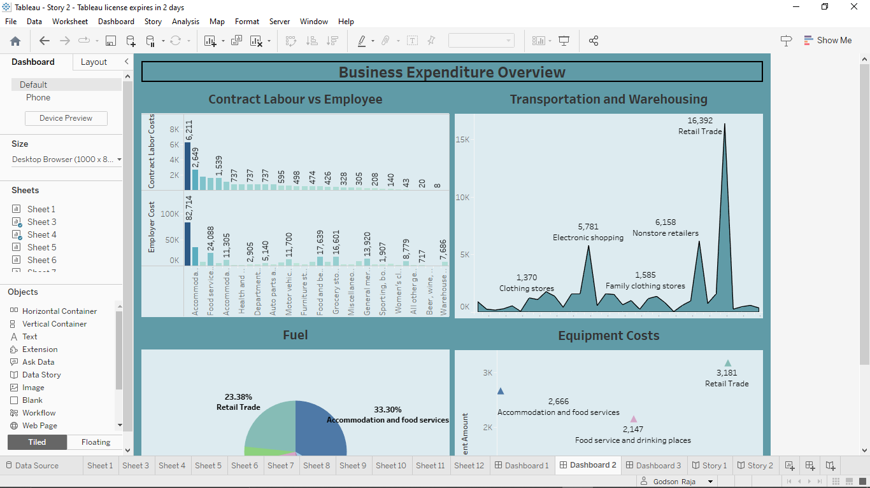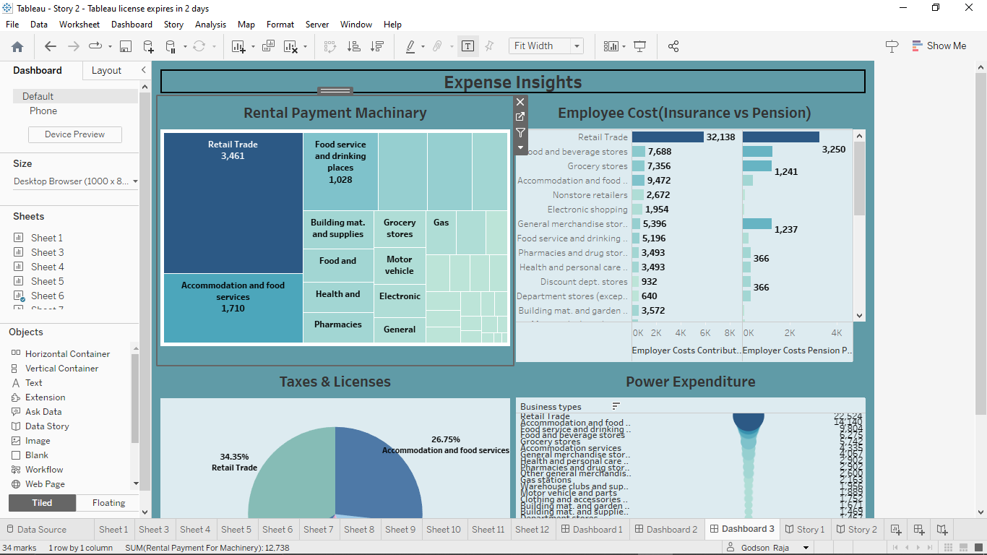

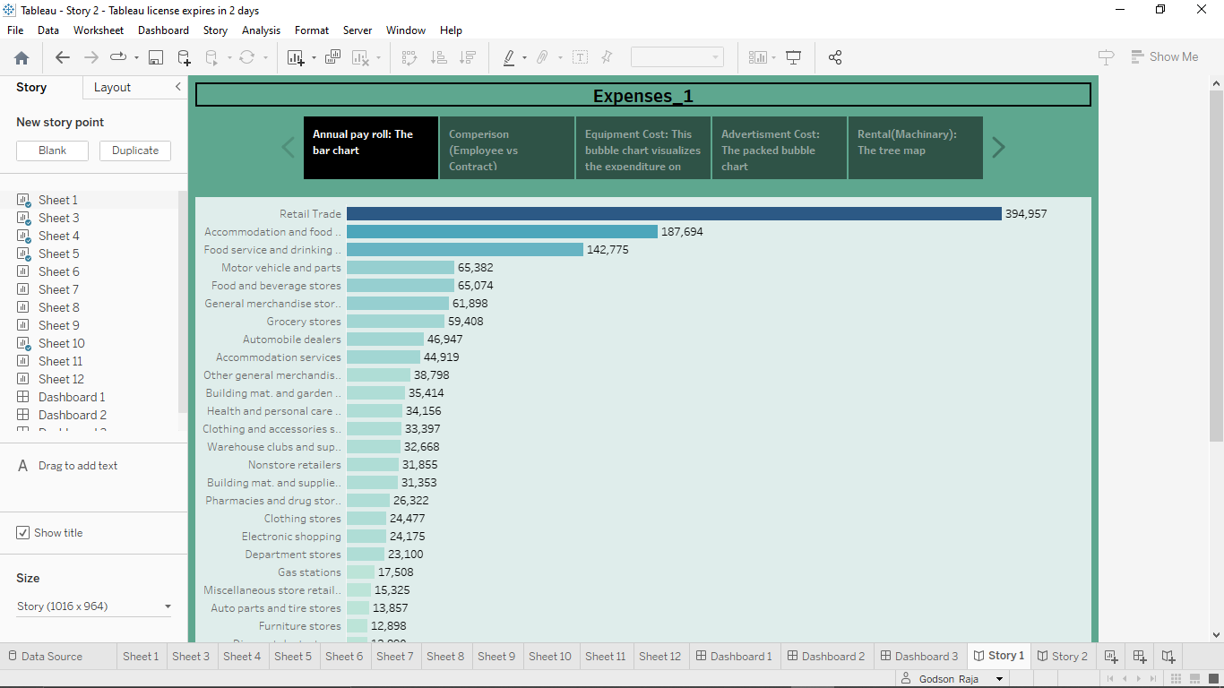

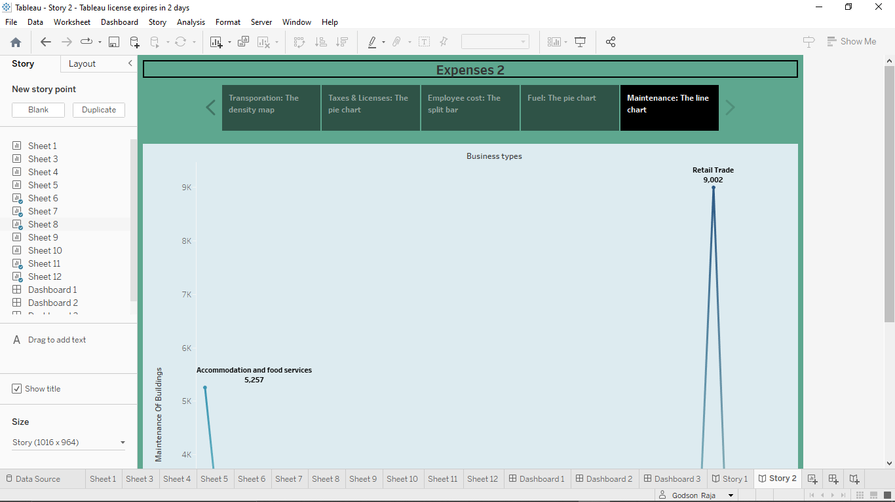

# 3. ADVANTAGES

Estimating business expenses is important for budgeting, evaluating cash flow, managing client expectations, and predicting the market cost of a project. It helps you understand which expenses are essential for your business and which ones can be reduced or eliminated

### DISADVANTAGES

One disadvantage of estimating business expenses is that it can be subjective and prone to errors, especially when assigning values to certain factors

# 4. APPLICATIONS

Estimating business expenses is important for budgeting, evaluating cash flow, managing client expectations, and predicting the market cost of a project. It helps you understand which expenses are essential for your business and which ones can be reduced or eliminated

# 5. CONCLUSION

Estimating business expenses is important for budgeting, evaluating cash flow, managing client expectations, and predicting the market cost of a project. It helps you understand which expenses are essential for your business and which ones can be reduced or eliminated